常州金马包装机械有限公司

DG-4000水冷式电磁感应铝箔封口机说明书

金马包装机械
DG-4000型水冷连续式电磁感应铝箔封口机
①概述
DG-4000电磁感应铝箔封口机是一种利用电磁感应原理，对瓶口上的铝箔片瞬间产生高热，从而将铝箔熔合在瓶口上，使其达到密封目的的理想封口设备。用铝箔封口机封口后产品具有良好的防潮、防霉作用，达到延长产品保存周期、防伪等目的。专用于医药、农药、食品、化妆品、润滑油等行业的封口环节。容器的材质可以是聚乙烯（PE）、聚丙聚（PP）、聚氯乙烯（PVC）、聚酯（PET）、聚苯乙烯（PS）以及玻璃等，不能用于金属瓶体及瓶盖。
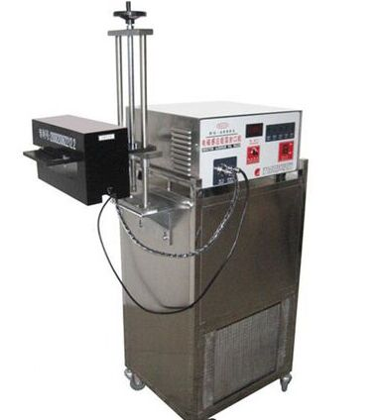
②设备特点
2.1、外壳采用优质不锈钢设计，既美观又符合GMP要求。
2.2、专利感应头性能强悍，立体式感应封口。
2.3、兼容各种封口功能，特别针对异形瓶封口。
2.4、循环水冷散热，促进功率发挥，高效迅猛。
2.5、内置智能稳压电源系统，功率恒定输出不受电压波动影响。
2.6、具备过压、过流、过热等自动保护功能。
2.7、启动无需预热即可工作，操作简单易懂。
2.8、具备自动检测诊断功能，信息及时反馈给操作者
③主要技术参数
3.1、电压频率：～220V±10%，50Hz
3.2、输出功率：4000Wmax
3.3、封口直径：Φ10～Φ60mm
3.4、封口速度：50-750瓶/分钟
3.5、包装尺寸：主机 460mm×410mm×210mm
3.6、感应头:300mm×130mm×150mm
3.7、水箱：520mm×450mm×800mm

DG-4000 water-cooled continuous electromagnetic induction aluminum foil sealing machine
①introduce:
DG-4000 electromagnetic induction aluminum foil sealing machine is an ideal sealing equipment that uses the principle of electromagnetic induction to instantly generate high heat on the aluminum foil on the bottle mouth, thereby fusing the aluminum foil to the bottle mouth to achieve the purpose of sealing. After being sealed with an aluminum foil sealing machine, the product has good moisture-proof and mildew-proof effects, which can achieve the purpose of extending the product storage period and preventing counterfeiting. Specially used in the sealing process of medicine, pesticide, food, cosmetics, lubricants and other industries. The material of the container can be polyethylene (PE), polypropylene (PP), polyvinyl chloride (PVC), polyester (PET), polystyrene (PS), glass, etc. Metal bottles and caps cannot be used.
②Equipment features
2.1. The shell is designed with high-quality stainless steel, which is both beautiful and in line with GMP requirements.
2.2. The patented sensor head has powerful performance and three-dimensional sensor sealing.
2.3. Compatible with various sealing functions, especially for sealing special-shaped bottles.
2.4. Circulating water cooling for heat dissipation promotes power development, high efficiency and rapidity.
2.5. Built-in intelligent regulated power supply system, constant power output is not affected by voltage fluctuations.
2.6. It has automatic protection functions such as overvoltage, overcurrent, and overheating.
2.7. It can work without preheating at startup, and the operation is simple and easy to understand.
2.8. It has automatic detection and diagnosis functions, and information is fed back to the operator in a timely manner.
③Main technical spcification
3.1. Voltage frequency: ~220V±10%, 50Hz
3.2. Output power: 4000Wmax
3.3. Sealing diameter: Φ10～Φ60mm
3.4. Sealing speed: 50-750 bottles/minute
3.5. Packing size: host 460mm×410mm×210mm
3.6. Induction head: 300mm×130mm×150mm
3.7. Water tank: 520mm×450mm×800mm

